Section 8.4: Exercise 8.14

8.14 Fair market value of Hawaiian properties. Prior to 1980, private homeowners in Hawaii had to lease the land their homes were built on because the law (dating back to the islands’ feudal period) required that land be owned only by the big estates. After 1980, however, a new law instituted condemnation proceedings so that citizens could buy their own land. To comply with the 1980 law, one large Hawaiian estate wanted to use regression analysis to estimate the fair market value of its land. Its first proposal was the quadratic model

(𝑦)=𝛽0+𝛽1𝑥+𝛽2𝑥2

Where

y = Leased fee value (i.e., sale price of property)

x = Size of property in square feet

Data collected for 20 property sales in a particular neighborhood, given in the table (p. 419), were used to fit the model. The least squares prediction equation is

𝑦^=−44.0947+11.5339𝑥−0.6378𝑥^2

1. Calculate the predicted values and corresponding residuals for the model.
2. Plot the residuals versus 𝑦^. Do you detect any trends? If so, what does the pattern suggest about the model?
3. Conduct a test for heteroscedasticity. [Hint: Divide the data into two subsamples, 𝑥≤12 and 𝑥>12, and fit the model to both sub-samples.]
4. Based on your results from parts b and c, how should the estate proceed?

HAWAII Data:

PROPERTY LEASEFEE SIZE

1 70.7 13.5

2 52.7 9.6

3 87.6 17.6

4 43.2 7.9

5 103.8 11.5

6 45.1 8.2

7 86.8 15.2

8 73.3 12

9 144.3 13.8

10 61.3 10

11 148 14.5

12 85 10.2

13 171.2 18.7

14 97.5 13.2

15 158.1 16.3

16 74.2 12.3

17 47 7.7

18 54.7 9.9

19 68 11.2

20 75.2 12.4

Section 8.3: Exercise 8.6

8.6 Demand for a rare gem. A certain type of rare gem serves as a status symbol for many of its owners. In theory, then, the demand for the gem would increase as the price increases, decreasing at low prices, leveling off at moderate prices, and increasing at high prices, because obtaining the gem at a high price confers high status on the owner. Although a quadratic model would seem to match the theory, the model proposed to explain the demand for the gem by its price is the first-order model

𝑦=𝛽0+𝛽1𝑥+𝜀

where y is the demand (in thousands) and x is the retail price per carat (dollars).

1. Fit this model to the 12 data points given in the table, and find the regression residuals.
2. Plot the residuals against retail price per carat, x.
3. Can you detect any trends in the residual plot? What does this imply?

GEM Data:

PRICE DEMAND

100 130

700 150

450 60

150 120

500 50

800 200

70 150

50 160

300 50

350 40

750 180

700 130

Section 8.5: Exercise 8.22

8.22 Cooling method for gas turbines. Refer to the Journal of Engineering for Gas Turbines and Power (January 2005) study of a high-pressure inlet fogging method for a gas turbine engine, Exercise 8.13 (p. 417). Use a residual graph to check the assumption of normal errors for the interaction model for heat rate (y). Is the normality assumption reasonably satisfied? If not, suggest how to modify the model.

ENGINE SHAFTS RPM CPRATIO INLET-TEMP EXH-TEMP AIRFLOW POWER HEATRATE

Traditional 1 27245 9.2 1134 602 7 1630 14622

Traditional 1 14000 12.2 950 446 15 2726 13196

Traditional 1 17384 14.8 1149 537 20 5247 11948

Traditional 1 11085 11.8 1024 478 27 6726 11289

Traditional 1 14045 13.2 1149 553 29 7726 11964

Traditional 1 6211 15.7 1172 517 176 52600 10526

Traditional 1 6210 17.4 1177 510 193 57500 10387

Traditional 1 3600 13.5 1146 503 315 89600 10592

Traditional 1 3000 15.1 1146 524 375 113700 10460

Traditional 1 3000 15 1171 525 514 164300 10086

Traditional 1 18000 12.7 1038 525 11 2000 14628

Traditional 1 11140 9.1 1038 523 25 5223 13396

Traditional 1 16630 15 1232 571 19 5500 11726

Traditional 2 7900 15.6 1077 482 47 11700 11252

Traditional 1 5100 10 963 485 123 26555 12449

Traditional 1 5160 12.3 1135 542 144 42170 11030

Traditional 1 3600 12.6 1113 534 295 86650 10787

Traditional 1 3000 12.3 1124 541 410 124700 10603

Traditional 1 3000 14.2 1204 553 515 172985 10144

Traditional 1 14000 15.9 1177 521 27 6930 11674

Traditional 1 3660 14.6 1135 526 56 14838 11510

Traditional 1 5400 15.3 1149 514 172 49500 10946

Traditional 1 3600 14.2 1141 526 362 109370 10508

Traditional 1 3600 11 1149 544 354 108719 10604

Traditional 1 3600 14.2 1177 525 378 120500 10270

Traditional 1 3000 14.2 1116 511 448 132220 10529

Traditional 1 3000 11.1 1149 537 500 157010 10360

Traditional 1 22516 6.6 899 512 7 1210 14796

Traditional 1 14950 9.7 916 444 19 3515 12913

Traditional 1 14950 10.7 1054 517 19 4600 12270

Traditional 1 14950 12 1093 513 22 5500 11842

Traditional 1 14950 15 1121 490 27 7520 10656

Traditional 2 8568 16.2 1066 464 39 9286 11360

Traditional 2 8568 17.6 1104 487 42 10685 11136

Traditional 1 11220 15.8 1121 493 49 13500 10814

Traditional 1 4473 8.9 960 517 158 32776 13523

Traditional 1 3600 12.4 1079 515 311 81600 11289

Traditional 1 3000 12.5 1041 490 400 100500 11183

Traditional 2 10400 15 1057 479 26 6844 10951

Advanced 1 6600 20 1288 546 120 43000 9722

Advanced 1 5100 14.8 1288 590 204 70905 10481

Advanced 1 3600 15.5 1327 599 448 174000 9812

Advanced 1 3600 18.5 1371 626 445 186600 9669

Advanced 1 3000 14.6 1327 599 648 259670 9643

Advanced 1 3000 23.2 1427 566 685 282000 9115

Advanced 1 3000 23.2 1427 621 685 331000 9115

Advanced 1 7280 14.3 1271 556 49 13680 11588

Advanced 1 7280 14.6 1271 556 88 27010 10888

Advanced 1 3600 16 1343 607 453 185400 9738

Advanced 1 3600 20 1427 596 567 254000 9295

Advanced 1 3000 17 1343 586 651 270300 9421

Advanced 1 3000 21 1427 587 737 334000 9105

Advanced 1 5400 16.1 1288 531 188 62300 10233

Advanced 1 5400 16.2 1310 589 187 68000 10186

Advanced 1 3600 16 1288 551 425 153600 9918

Advanced 1 3600 16.9 1343 577 440 182000 9209

Advanced 1 3600 15 1349 590 450 186500 9532

Advanced 1 3000 14 1260 585 510 189000 9933

Advanced 1 3600 19.2 1427 594 550 253000 9152

Advanced 1 3000 17 1316 584 642 265540 9295

Aeroderiv 2 33000 6.9 888 513 3 486 16243

Aeroderiv 2 30000 8.5 1004 561 4 806 14628

Aeroderiv 2 18910 14 1066 532 8 1845 12766

Aeroderiv 3 3600 35 1288 448 152 57930 8714

Aeroderiv 3 3600 20 1160 456 84 25600 9469

Aeroderiv 2 16000 10.6 1232 560 14 3815 11948

Aeroderiv 1 14600 13.4 1077 536 20 4942 12414

Section 8.6: Exercise 8.28

8.28 Measuring the Moon’s orbit. Refer to the American Journal of Physics (April 2014) study of the Moon’s orbit, Exercise 8.11 (p. 417). A MINITAB printout with influence diagnostics for the first-order model relating angular size (y) to height above horizon (x) is shown below. [Note: Leverage values are in the HI column.] Use this information to find any influential observations.

8.11 Measuring the Moon’s orbit. Refer to the American Journal of Physics (April 2014) study of the Moon’s orbit, Exercise 3.9 (p. 103). Recall that pictures were used to measure the angular size (in pixels) of the Moon at various distances (heights) above the horizon (measured in degrees). The data for 13 different heights are reproduced in the accompanying table. In Exercise 3.9, you fit a first-order model relating angular size (y) to height above horizon (x).

3.9 Measuring the Moon’s orbit. A hand-held digital camera was used to photograph the Moon’s orbit, and the results were summarized in the American Journal of Physics (April 2014). The pictures were used to measure the angular size (in pixels) of the Moon at various distances (heights) above the horizon (measured in degrees). The data for 13 different heights are illustrated in the graph (next page) and saved in the MOON file.

The scatterplot has the following points. (17, 321.9), (17.5, 322.2), (27, 322.25), (32, 323.2), (39, 323.3), (41, 324.4), (50, 324.9), (52, 325.7), (57, 325.75), (60, 324.8), (65, 326.2), (67, 325.8), and (75, 325.7). All values estimated.

1. Is there visual evidence of a linear trend between angular size (y) and height above horizon (x)? If so, is the trend positive or negative? Explain.
2. Draw what you believe is the best fitting line through the data.
3. Draw vertical lines from the actual data points to the line, part b. Measure these deviations, then compute the sum of squared deviations for the visually fitted line.
4. A SAS simple linear regression printout for the data is shown on the next page. Compare the y-intercept and slope of the regression line to the visually fitted line, part b.
5. Locate SSE on the printout. Compare this value to the result in part c. Which value is smaller?

ANGLE HEIGHT

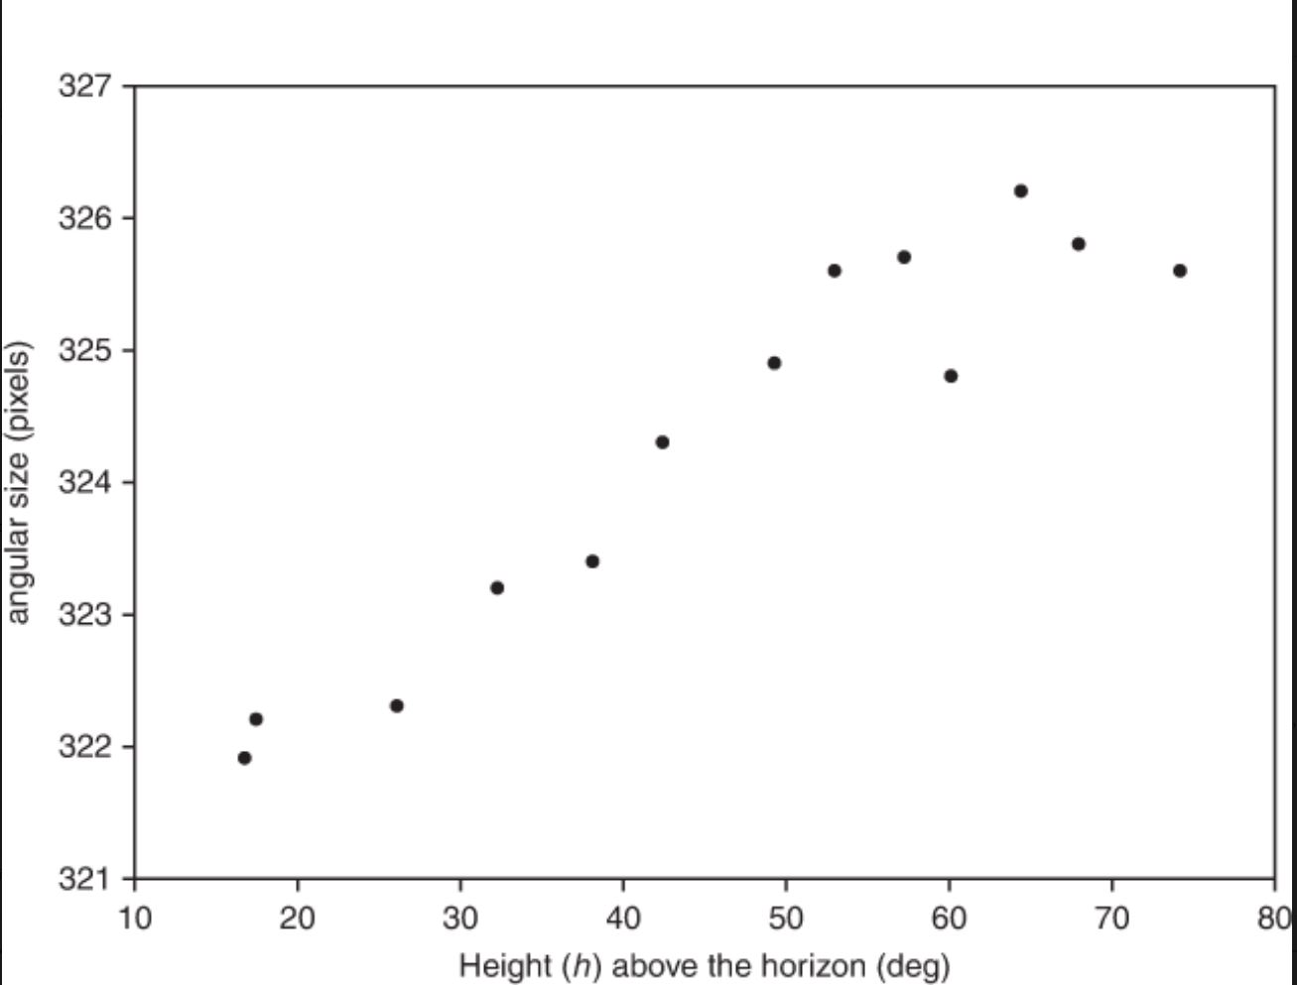

321.9 17

322.3 18

322.4 26

323.2 32

323.4 38

324.4 42

325 49

325.7 52

325.8 57

325 60

326.9 63

326 67

325.8 73

Chapter 8 Supplemental: Exercise 8.52

8.52. Analysis of television market share. The data in the table are the monthly market shares for a product over most of the past year. The least squares line relating market share to television advertising expenditure is found to be

𝑦^=−1.56+.687𝑥

1. Calculate and plot the regression residuals in the manner outlined in this section.
2. The response variable y, market share, is recorded as a percentage. What does this lead you to believe about the least squares assumption of homoscedasticity? Does the residual plot substantiate this belief?
3. What variance-stabilizing transformation is suggested by the trend in the residual plot? Refit the first-order model using the transformed responses. Calculate and plot these new regression residuals. Is there evidence that the transformation has been successful in stabilizing the variance of the error term, ε?

TVSHARE Data:

MKTSHR ADVEXP

15 23

17 27

17 25

13 21

12 20

14 24

16 26

14 23

15 25